PENTECOST UNIVERSITY
P. O. Box KN 1739, Kaneshie, Accra-Ghana
Tel: 0302417057/8, Website: www.pentvars.edu.gh

SCHOOL OF THEOLOGY, MISSION
& LEADERSHIP
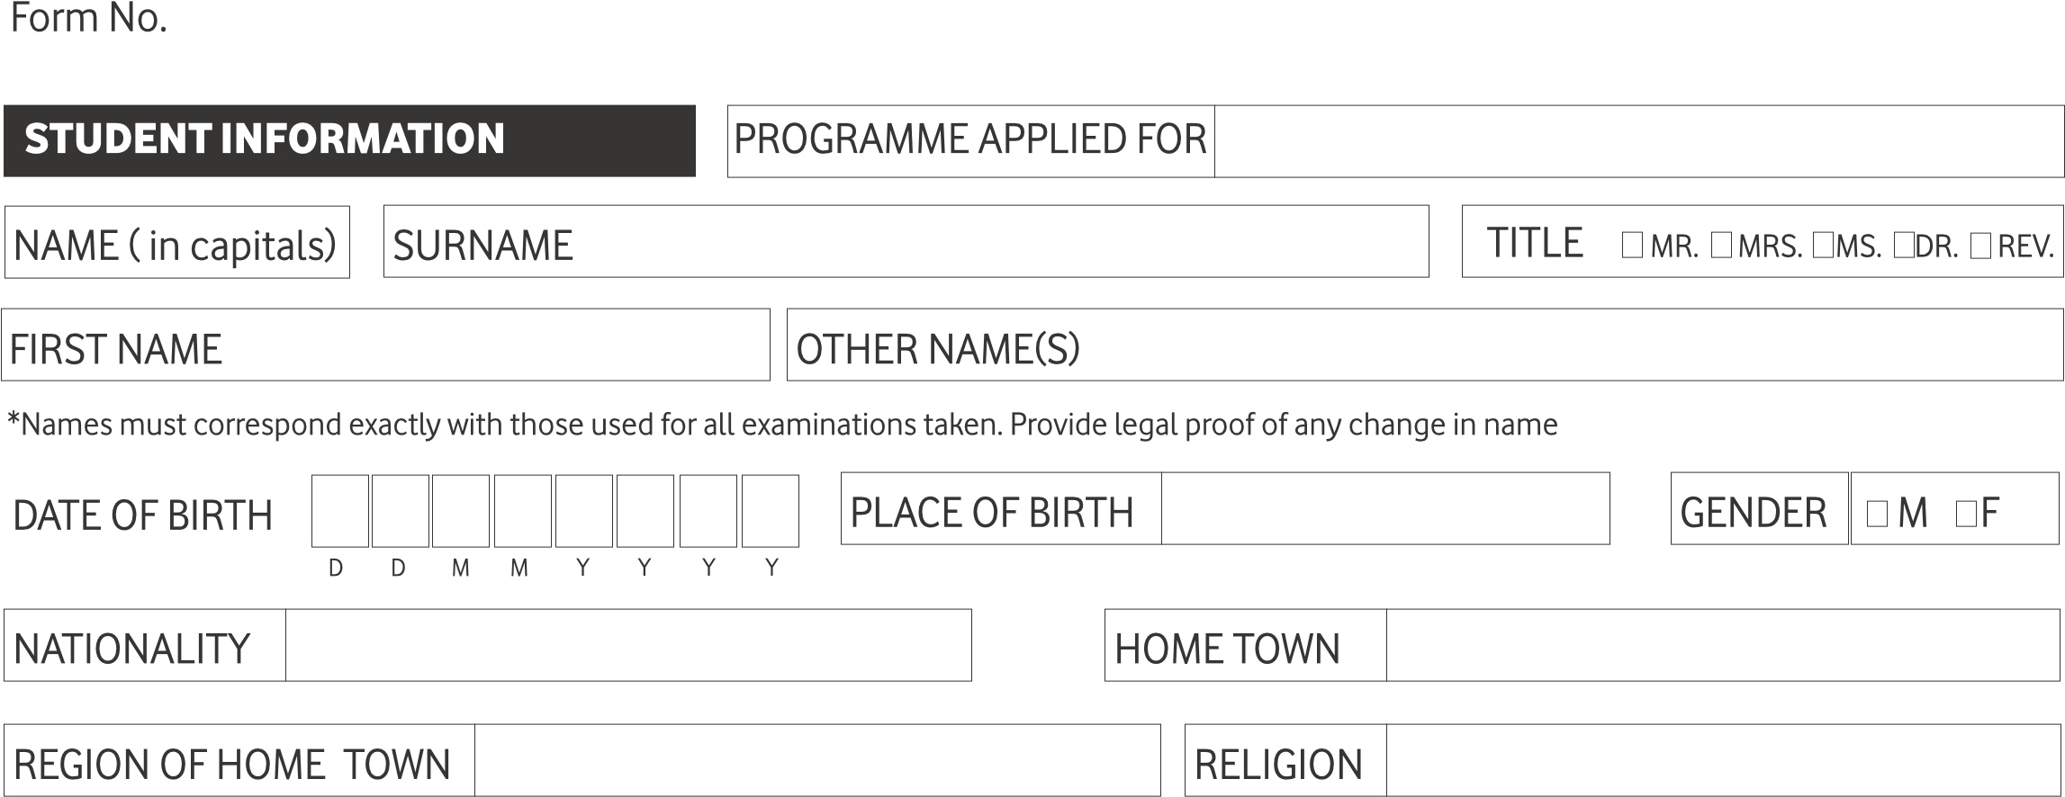
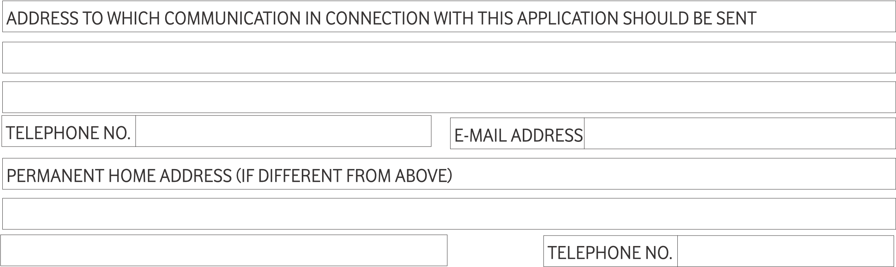
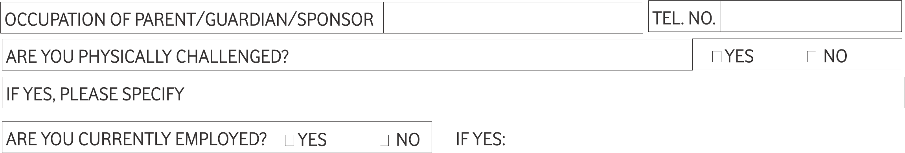

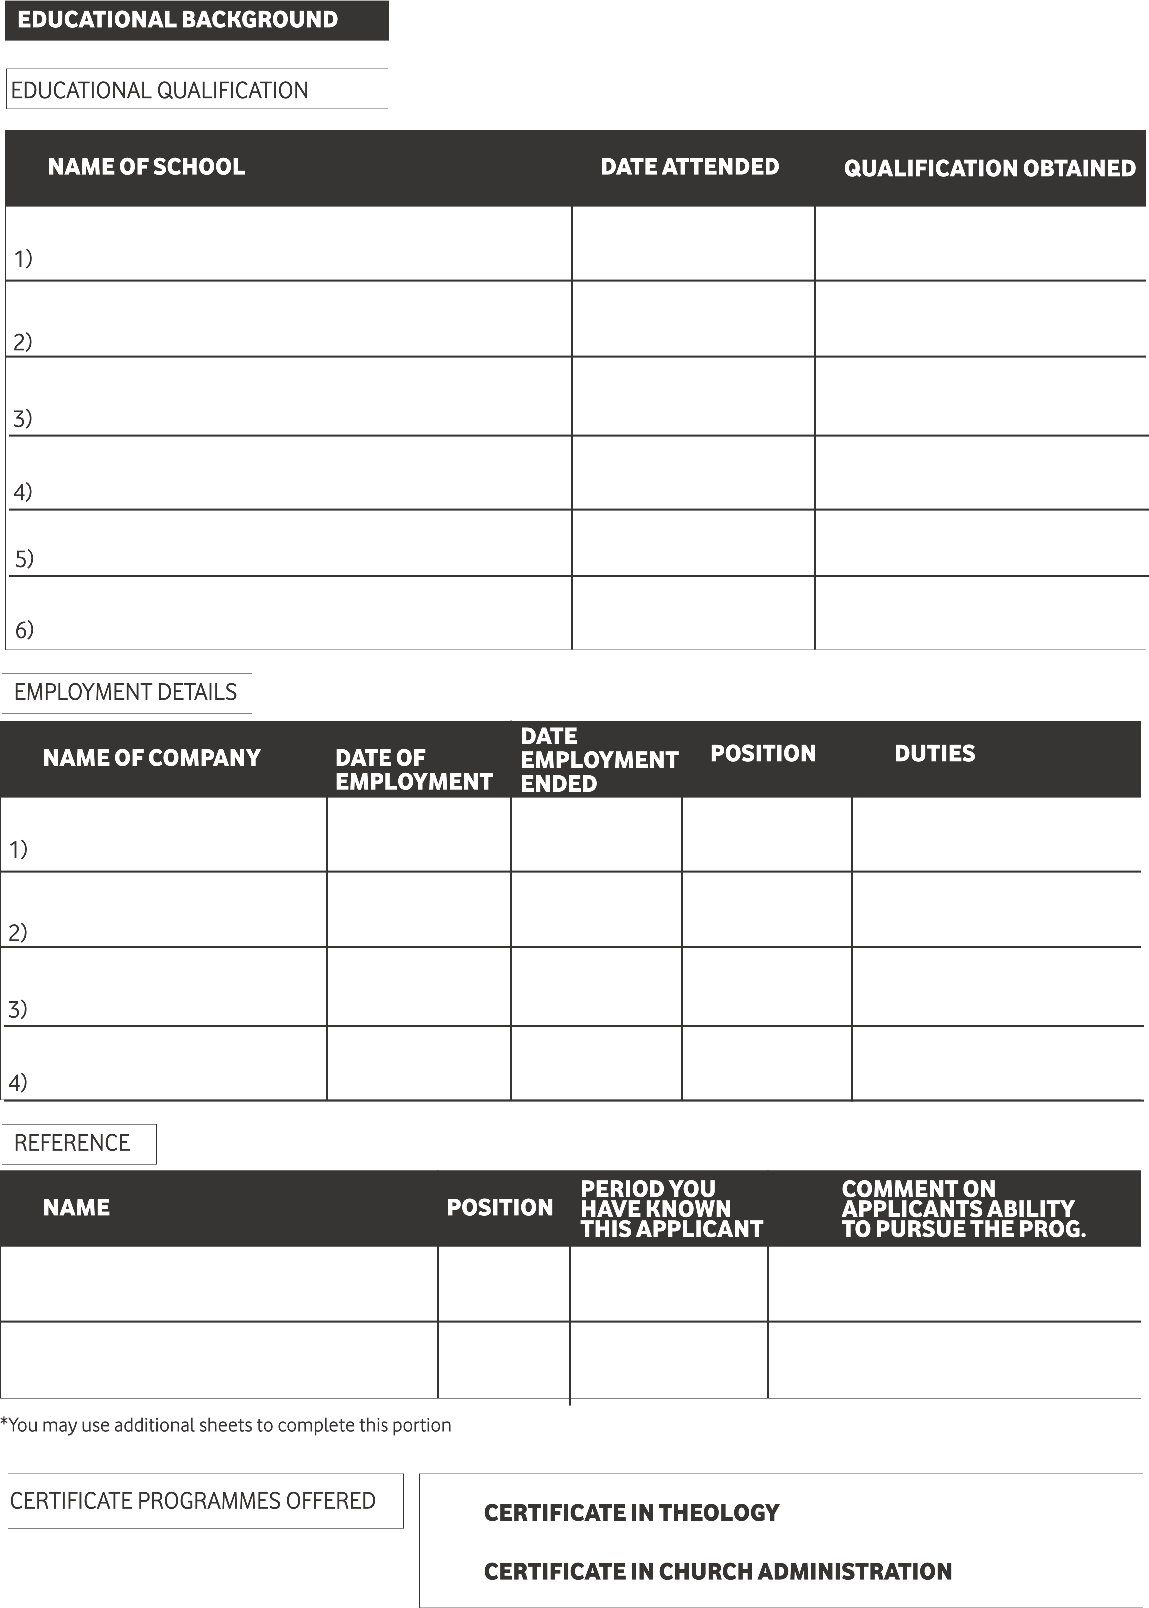
CERTIFICATE IN THEOLOGY AND CHURCH ADMINISTRATION
CERTIFICATE IN LEADERSHIP AND COUNSELLING

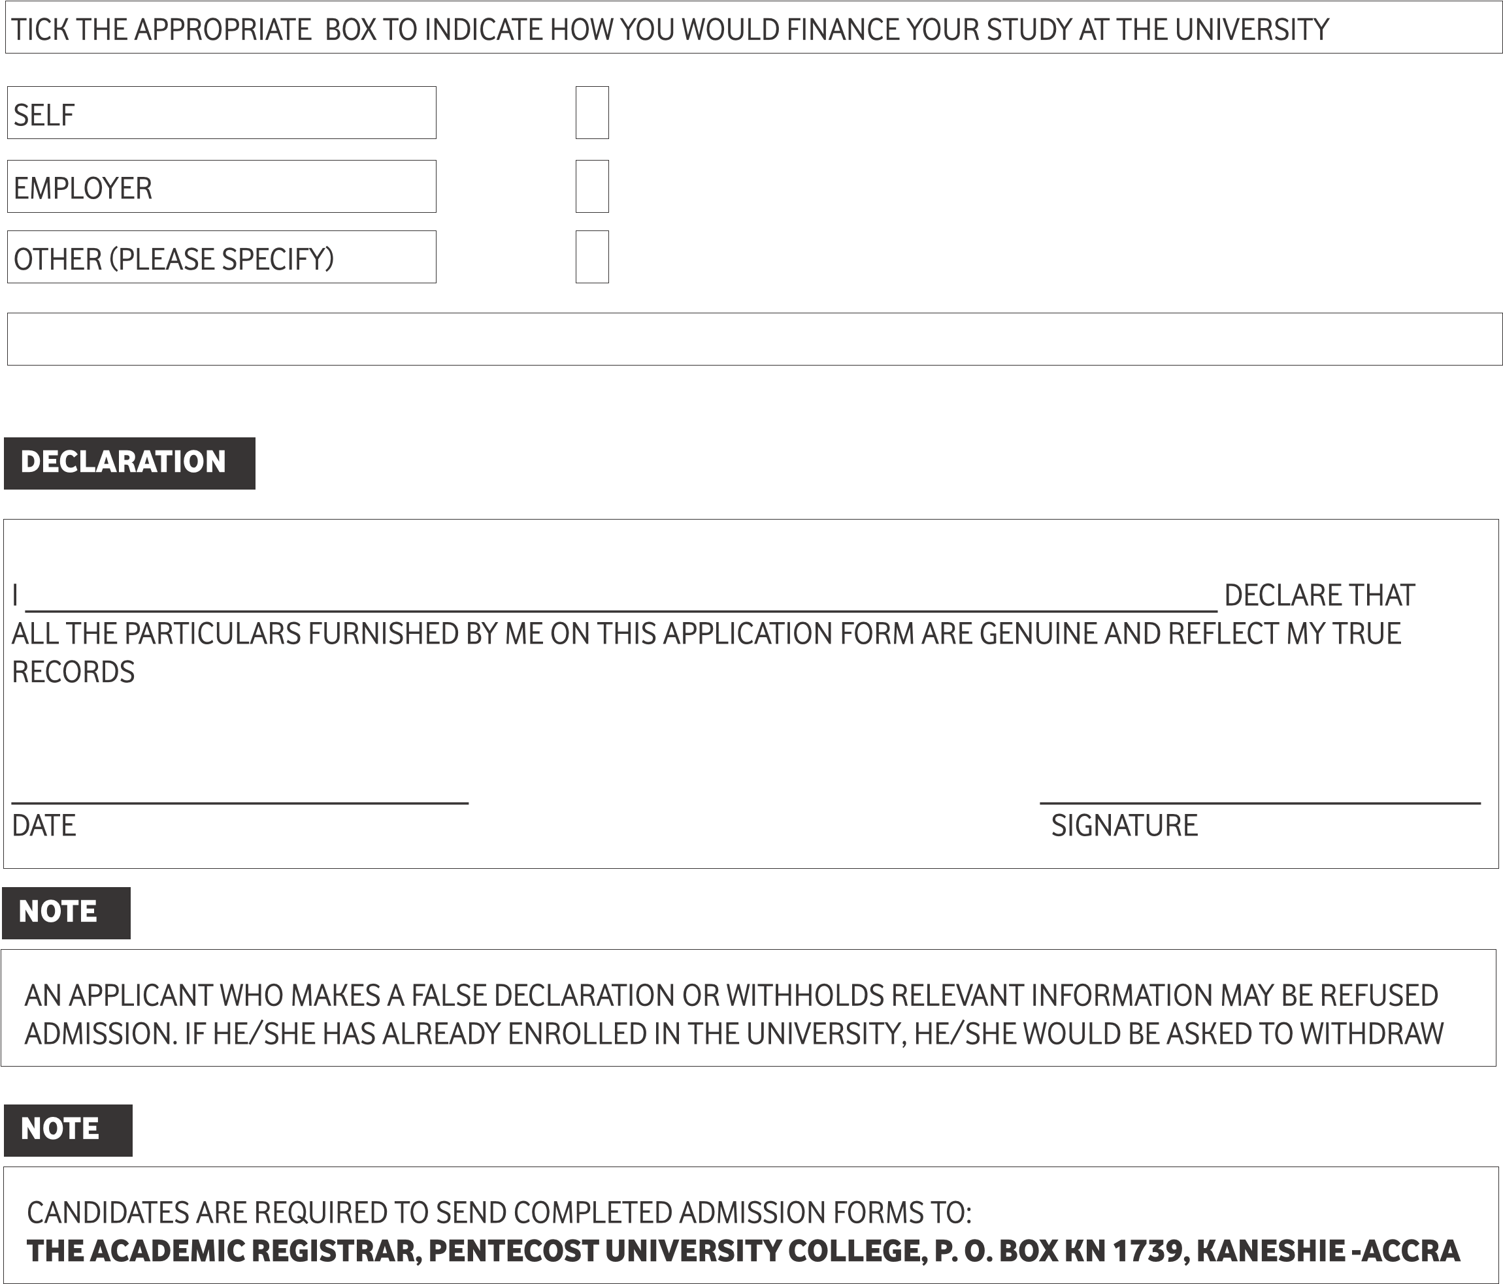
CANDIDATES ARE REQUIRED TO SEND COMPLETED ADMISSION FORMS TO:
PENTECOST UNIVERSITY, SCHOOL OF THEOLOGY MISSION AND LEADERSHIP (STML), P.O. BOX KN 1739, KANESHIE – ACCRA
EMAIL: STMLADMISSIONS@PENTVARS.EDU.GH

FURTHER CONTACT: +233 202 848 498 +233 274 924 750 +233 244 072 950

